Bildlegende / Foto Credits, Regionale 23 – Performing Traces
Basel, 14.11.2022
Denise Blickhan::
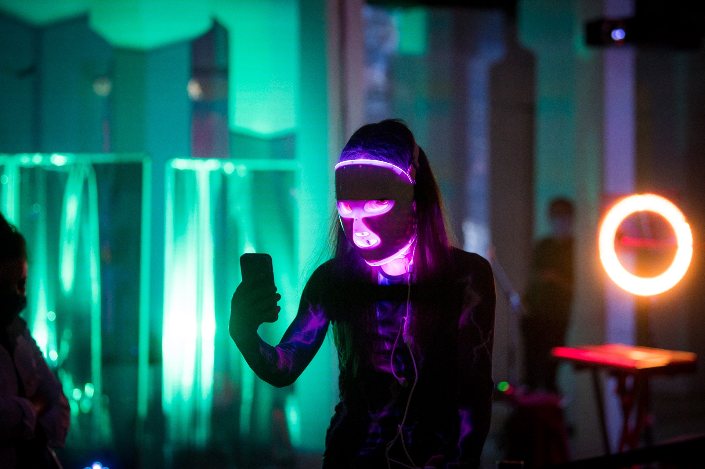
Denise Blickhan, MEDUSA 10 (iconoclasms), 2020, installation view GG_EWERK, Photo: Marc Doradzillo, courtesy of the artist
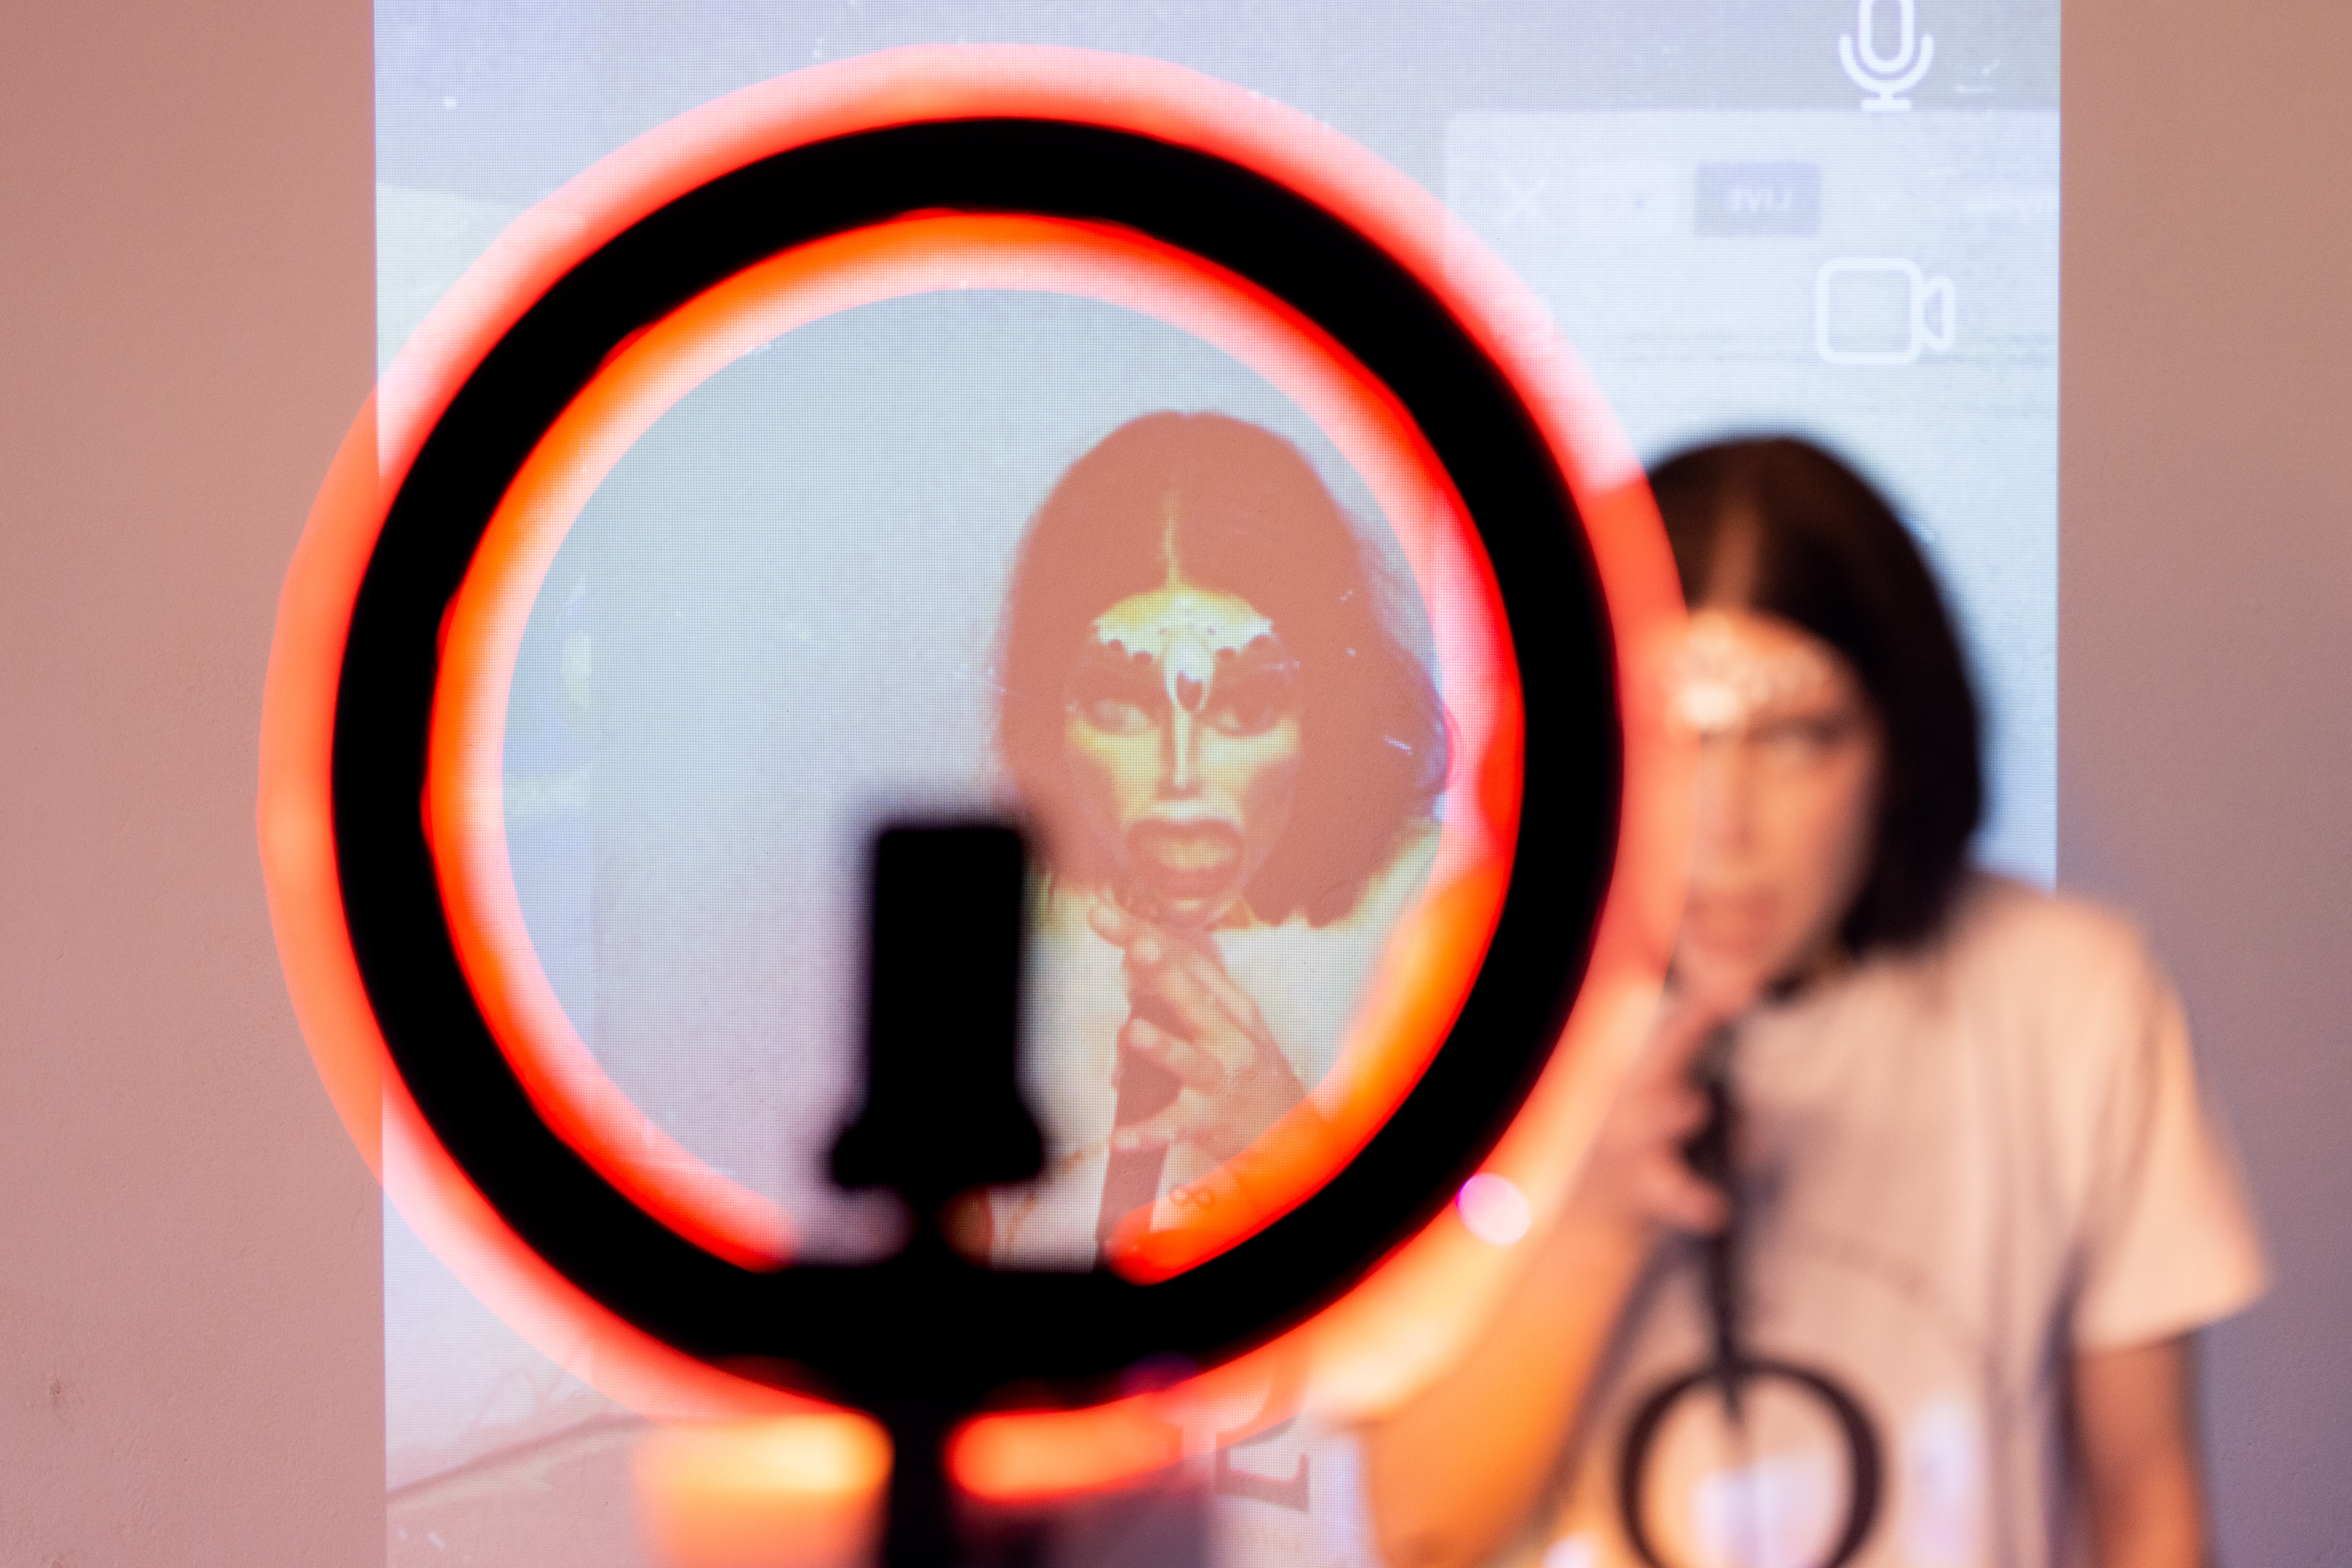
Denise Blickhan, MEDUSA X, 2022, installation view, Photo: Dirk Rose, Mouches Volantes 6
Denise-Blickhan, Hello Daddy-(M7,8,9), 2019, video still, courtesy of the artist

Susi Hinz:
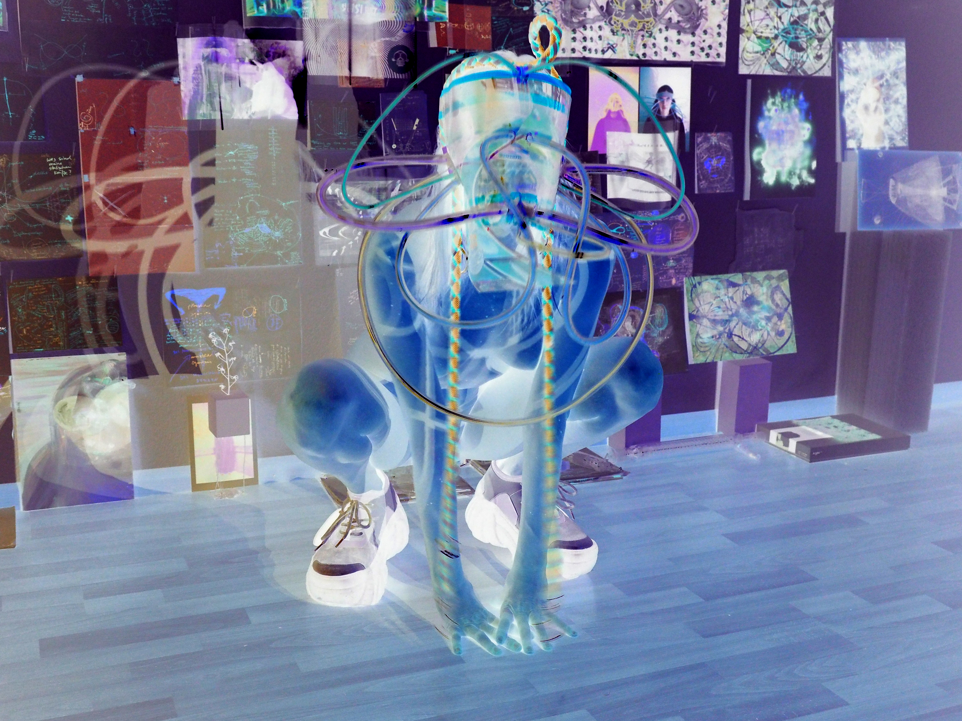
Susi Hinz, Transhydranlightwarrior, TRANSHYDRAN MASC, 2022, Photo: Andrii Klymenko, courtesy of the artist
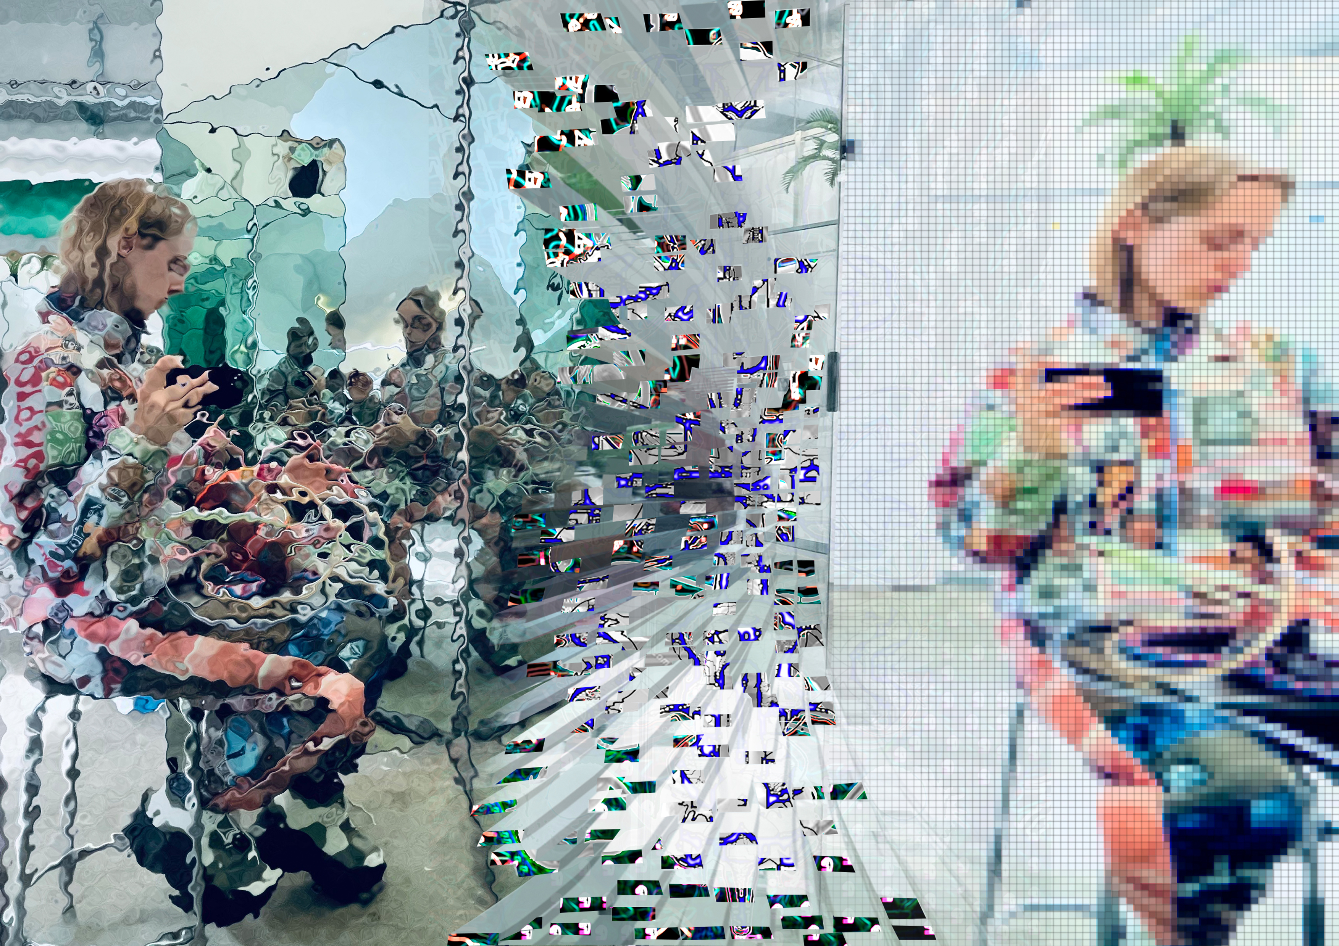
Susi Hinz, TRANSHYDRAN MASC & TREUEANZUG, 2022, digital collage, courtesy of the artist
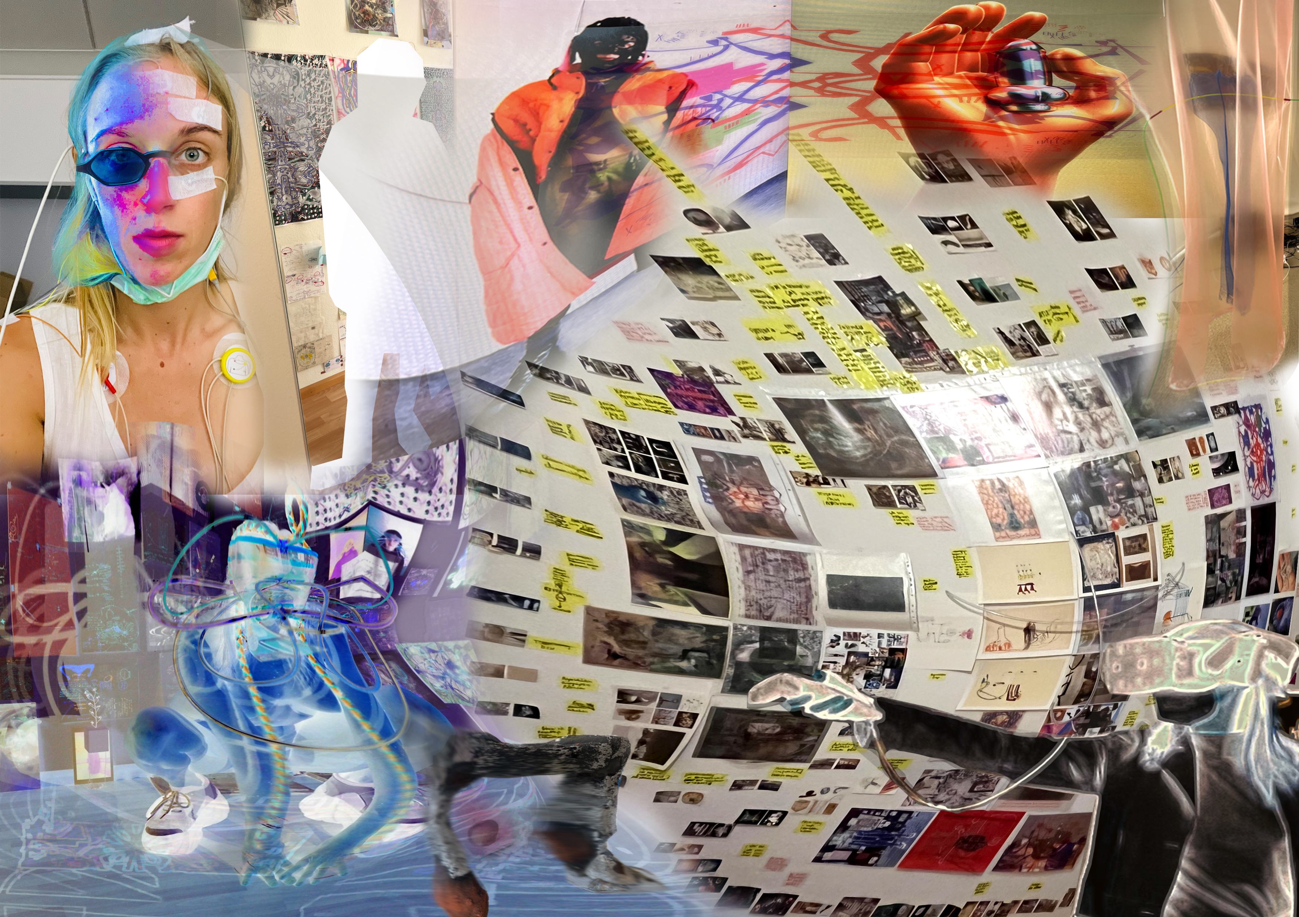
Susi Hinz, TRANSHYDRAN PHASES 1-4, 2022, video still, courtesy of the artist

